CHILDREN’S ORAL HEALTH
PROGRAM
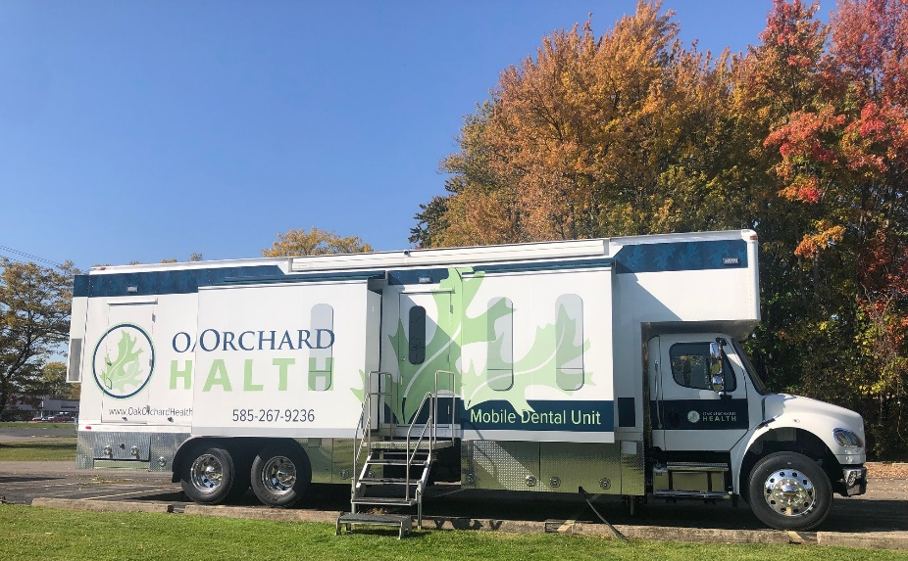

300 West Avenue, Brockport NY 14420
585-267-9236 Mobile Dental Unit
585-637-3905 Main Office
585-589-5613 Albion Dental
585-637-0240 Vision Services
585-258-3386 Emergency After-Hours

VISION SCREENINGS ARE AVAILABLE!

Dear Parent or Guardian:
- The Oak Orchard Health Mobile Dental Unit will be visiting your child’s school. The Mobile Dental Unit will be open during regular school hours to provide oral health services for children who currently do not have a dentist and are enrolled in:
- Medicaid - Child Health Plus - Other dental insurance
- Sliding fee program based on family income - Self-pay (no insurance)

Please call the Oak Orchard Health Mobile Dental Unit at 585-267-9236 for details.

- With your approval, your child(ren) will receive a complete dental check-up, including x-rays, a dental cleaning, and a fluoride application for cavity prevention. Other services that will be provided, as needed, include sealants, fillings, stainless steel crowns, and extractions. Local anesthesia (to numb the tooth) is used when necessary. Vision screenings are also available.

- If you want your child to receive a dental check-up and any necessary services, PLEASE FILL OUT THE ATTACHED FORM AND RETURN IT TO YOUR CHILD’S TEACHER AS SOON AS POSSIBLE. Emergency care will be provided as necessary (for example, if your child falls and injures a tooth). Emergency after-hours support is offered 7 days a week, please call 585-258-3386 if needed.

If you need help filling out the form, please feel free to visit the Mobile Dental Unit before or after school, or you may call 585-267-9236 for assistance. Your child can continue their dental treatment at any of our Oak Orchard locations including Brockport, Warsaw, Hornell, and Albion.

*Vision screenings are offered in the Mobile Dental Unit*
- The Spot Vision Screener is a tool that can help identify if your child has a vision issue that needs further evaluation and treatment by a vision provider. A report with dental and vision screening results will be sent home to parents.
- Please call the Oak Orchard Optical Department at 585-637-0240 for details

*Comprehensive Eye Exams at an Eye Doctor’s office are recommended for all children when they start school. Please be aware that most health insurance plans will cover a comprehensive eye exam. If your child already wears eyeglasses, a vision screening is not necessary. We recommend they keep their regular eye exam visits with their eye doctor.
I would like my child(ren) to receive the following services (please check one):
□ Dental Treatment and Vision Screening □ Dental Treatment Only □ Vision Screening Only
Child’s Name: ___________________________________________________ Sex: ______ Date of Birth: _______________
Address: _________________________________________________ City: ____________________ Zip: _______________
Phone #: _______________________________________ SSN: ______________________________
Emergency Contact Name: __________________________________________ Phone #: ___________________________
Race or Ethnic Background: □ Asian □ Bi-Racial □ Native American □ Black □ Hispanic □ White, Non-Hispanic or Non-Asian
Other: ________________________________________
Child’s Medicaid #: _____________________________________ Child Health Plus #: ______________________________
Other dental insurance: ________________________________________________________________________
My child does not have Medicaid/Child Health Plus. Please call me at (best phone number): _________________________
regarding Child Health Plus Dental Insurance/Medicaid/sliding fee information.
Medical Doctor/Clinic Name: ________________________________________ Phone #: ____________________________
Medication your child is taking: ____________________________________________________________________
Illnesses your child is being treated for: _____________________________________________________________
Problems your child has been hospitalized for: _______________________________________________________
Is your child allergic or had any unusual reactions to: Penicillin □ Yes □ No Aspirin □ Yes □ No
Novocaine □ Yes □ No Latex □ Yes □ No
Other allergies you child may have: ________________________________________________________________
Is this your child’s first dental visit? □ Yes □ No
Previous Dentist Name: __________________________________________ Last visit: _____________________
Is your child currently seeing a dentist? If yes, please provide their name/number:_________________________
Has your child had any of the following?
YES | NO |  |  | YES | NO
 |  | Heart Disease |  |  |  | Asthma
 |  | Heart Murmurs |  |  |  | Lung Disease
 |  | Rheumatic Fever |  |  |  | Tuberculosis
 |  | Kidney Disease |  |  |  | Anemia
 |  | Hepatitis/Liver Disease |  |  |  | Sickle Cell Disease
 |  | Diabetes |  |  |  | Sickle Cell Trait
 |  | High Lead Levels |  |  |  | Hemophilia
 |  | Speech/Hearing Problems |  |  |  | Prolonged Bleeding
 |  | Emotional Disorders |  |  |  | Blood Transfusion
 |  | Epilepsy/Seizures |  |  |  | HIV/AIDS

I give my permission for my child to receive a dental cleaning,exam and X-rays, fillings, extractions, pulp therapy, stainless steel crowns, fluoride application and sealants. Local anesthesia may be given, and if so, I understand that care must be taken not to rub or bite lips/cheeks/tongue after procedures to avoid possible injury, swelling or bleeding. I may discontinue my child’s treatment at any time with written notification. I understand that discontinuing needed treatment may lead to possible pain, infection, swelling and increased decay/disease. I understand that photographs may be taken of my child for treatment related purposes. I consent to the release of medical information from my child’s medical doctor to clarify health concerns. The above medical history is complete and accurate. I consent to communication with my child’s previous or regular source of dental care regarding treatment provided on the MDU and treatment still needed. The information obtained from the vision screening is preliminary and does not constitute a diagnosis of vision problems. I know that I am responsible for getting a full eye exam with an eye doctor of my choosing if my child is referred as a result of the vision screening. The Vision Screener does not take the place of regular comprehensive eye exams at my eye doctor’s office.

Signature of Parent/Legal Guardian: ____________________________________________ Date: ____________
Please Print Parent/Legal Guardian Name: ______________________________________________
Parent/Legal Guardian Birthdate: _________________________
DENTAL ENROLLMENT FORM

Please return this form to:

SCHOOL NAME: _______________________________________________________

TEACHER: ____________________________________________________________

-------------------------------------------------------------------------------------------------------
Please do not write on this part of the form. Thank you.

The enclosed health history has been reviewed.

There are no contraindications to dental care.

Significant findings were noted and a parent/legal guardian was informed and/or medical consult was made.

Provider Signature: __________________________________ Date:
DDS DMD RDH

